**Lab: AWS NAT Instance configuration**

**Services Used: EC2**

**Introduction:** AWS NAT instance is an alternate way of providing outbound internet access to private instances. The right configuration is to use NAT gateway for this purpose however it is chargeable. For smaller environment or test/dev environment NAT instance can server this purpose.

1. Install a t2.micro EC2 instance with AWS NAT AMI following the below procedure in public subnet.

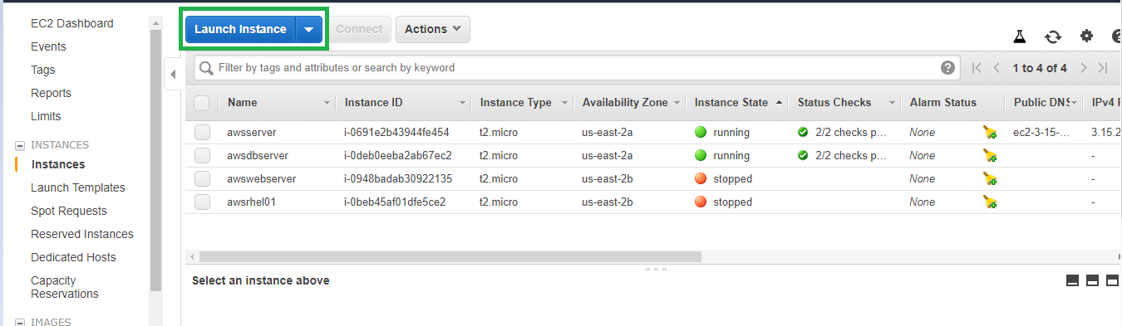

1. Search NAT in the AMI and choose the latest available AWS NAT AMI

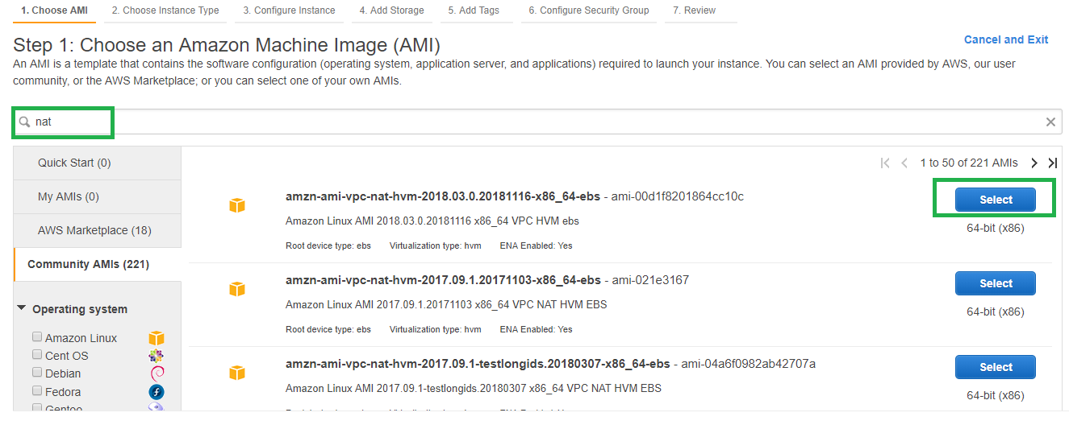

1. Choose the appropriate instance type. Use t2.micro for free tier.

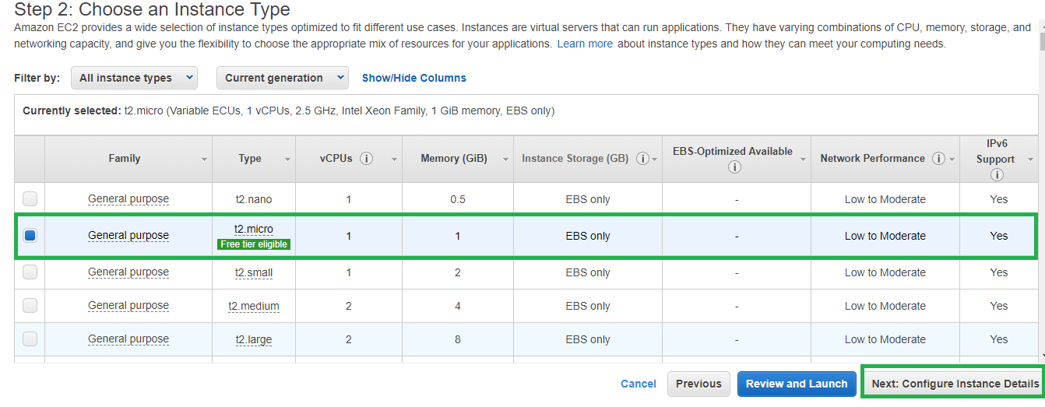

1. Launch the instance in public subnet.

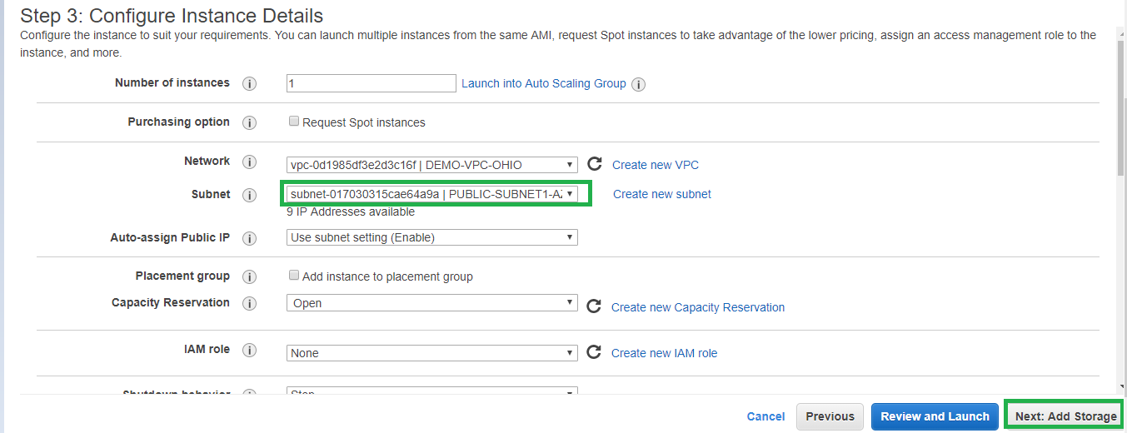

1. Configure storage, Tags as per requirement.

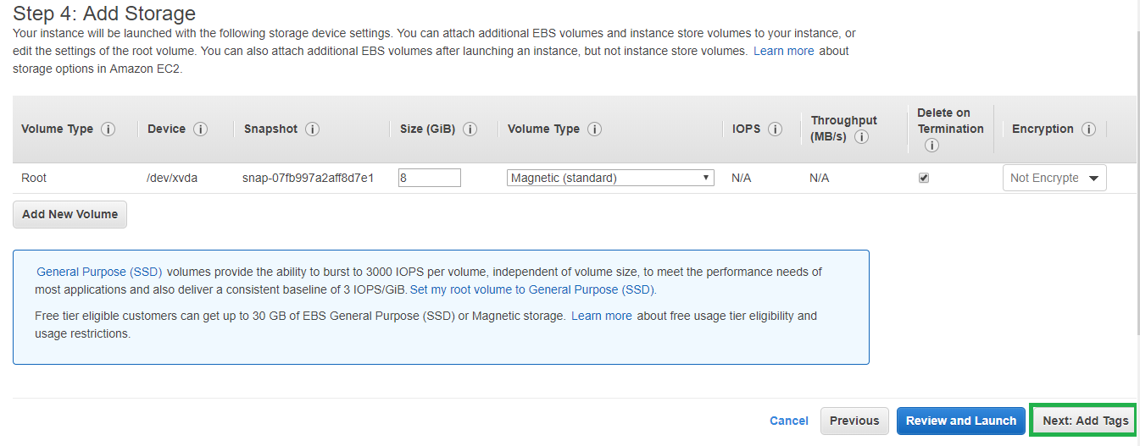

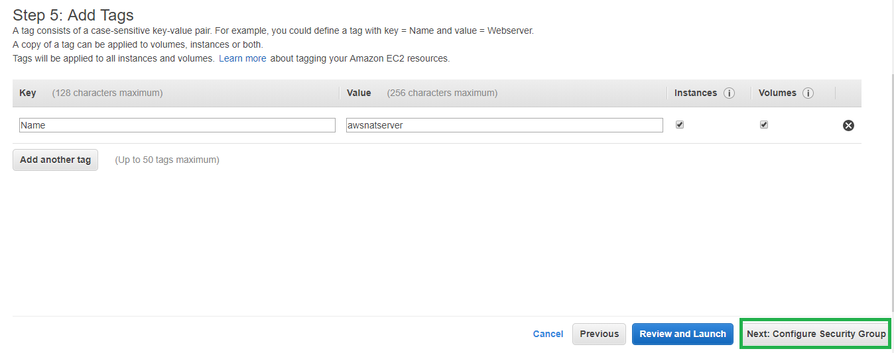

1. Create or select NAT security group. The security group should allow inbound http/https traffic from the private instance security group or the private subnet CIDR that require internet access.

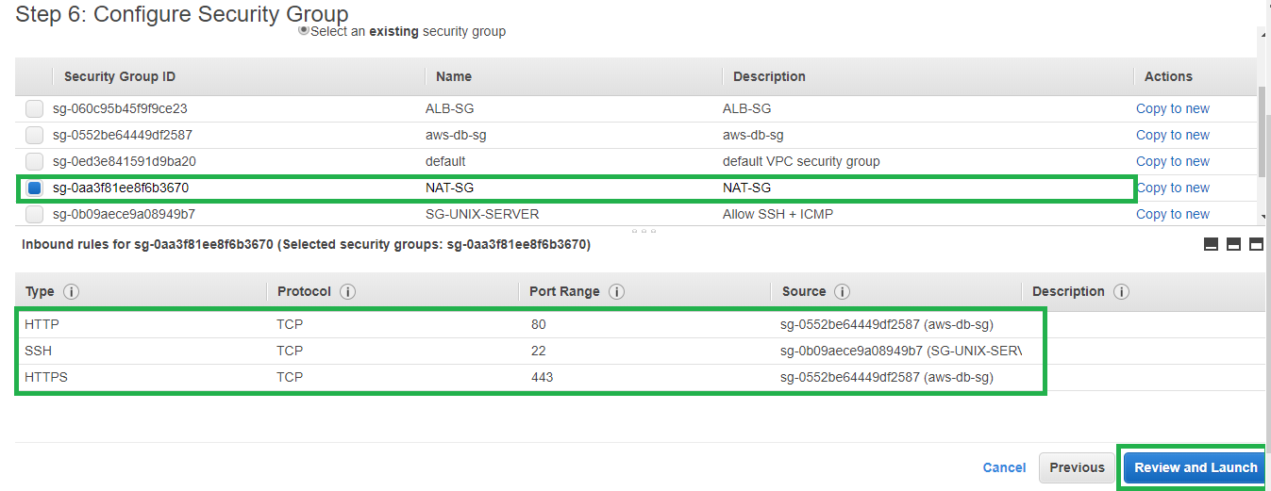

1. Review the other instance settings and launch the instance.

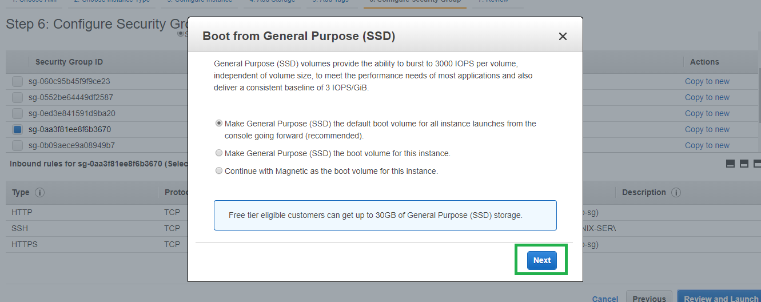

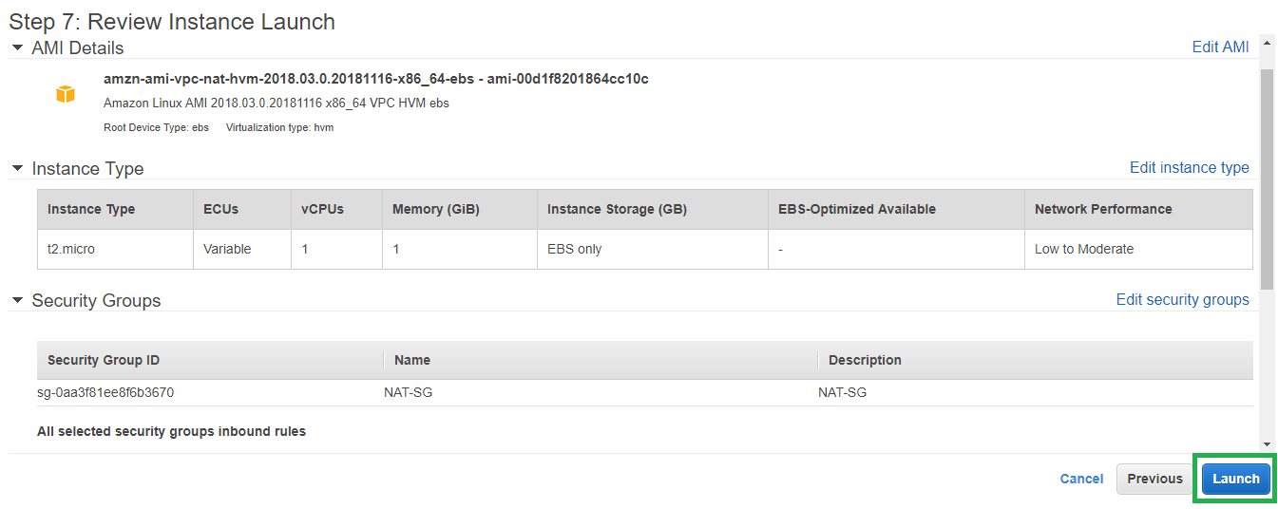

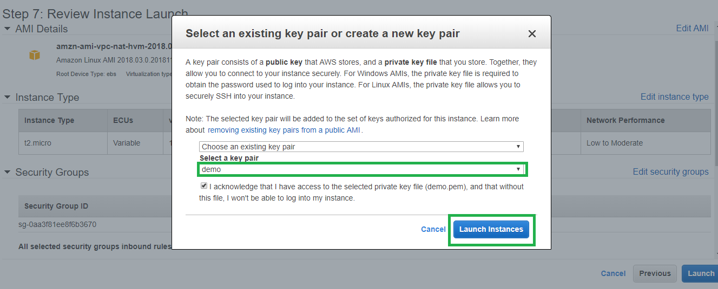

1. Once the instance is launched. Disable the source and destination check. This is required for NAT instance functionality.

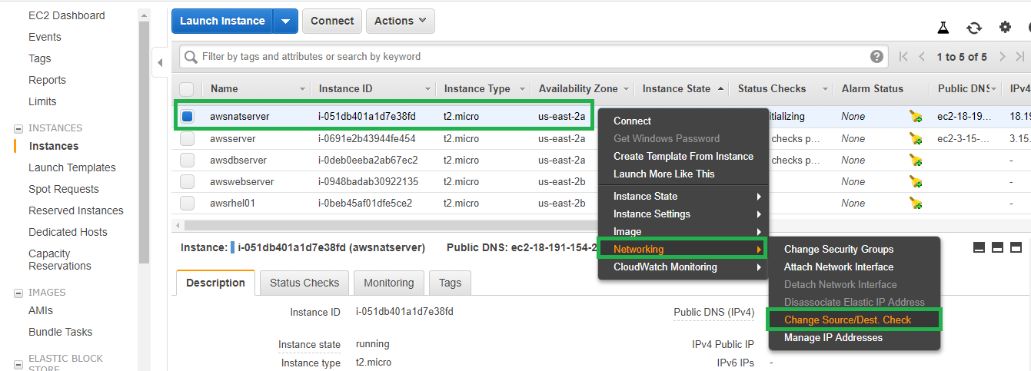

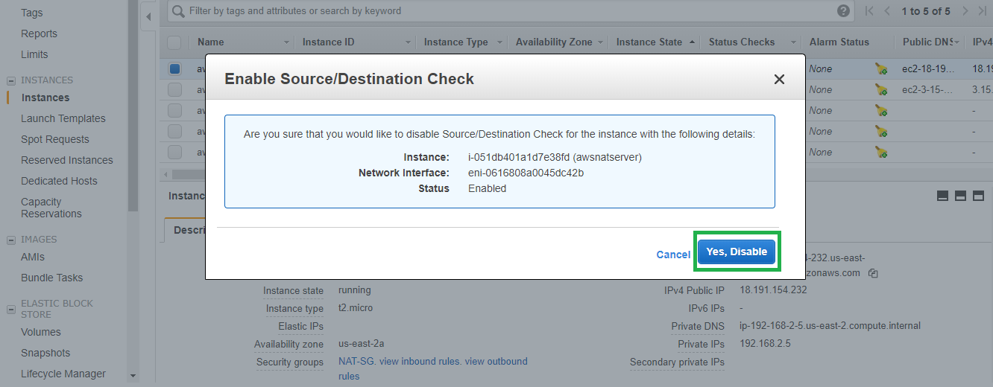

1. Update the private subnet routes to route any/internet traffic via the newly created NAT instance.

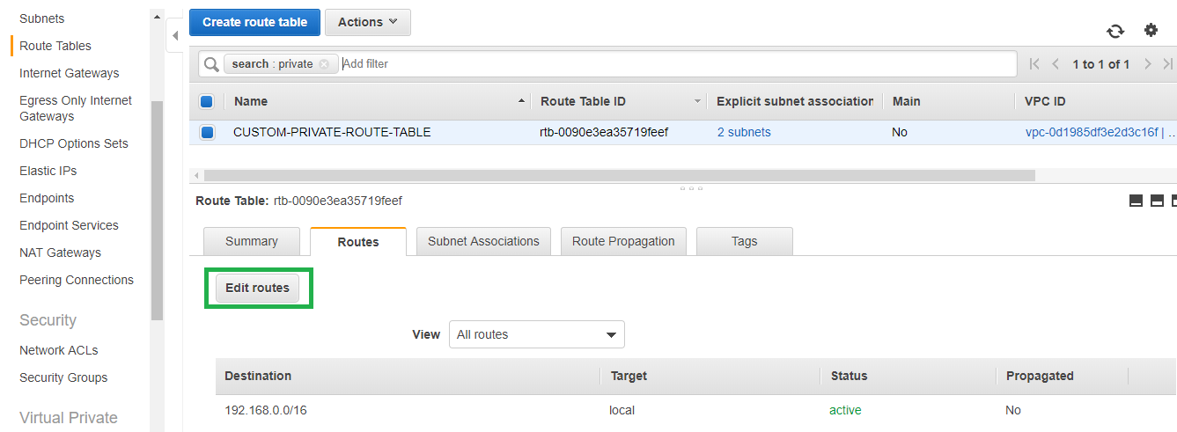

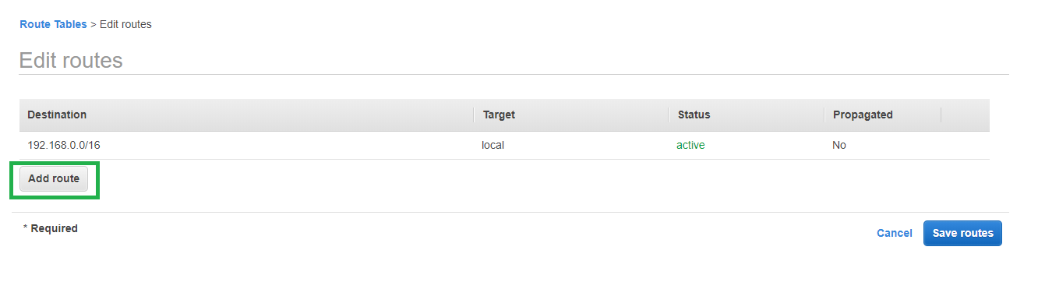

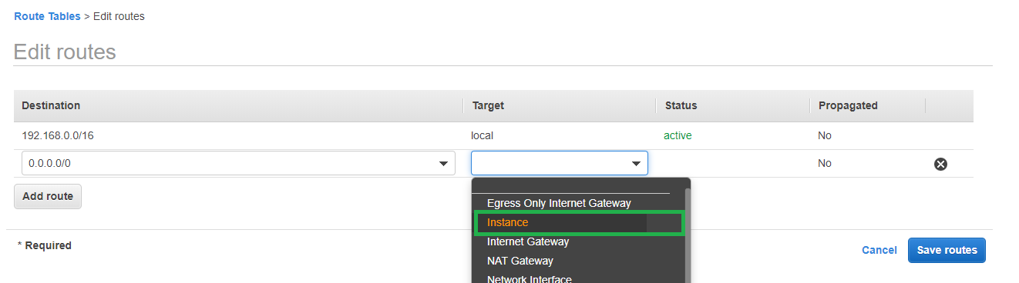

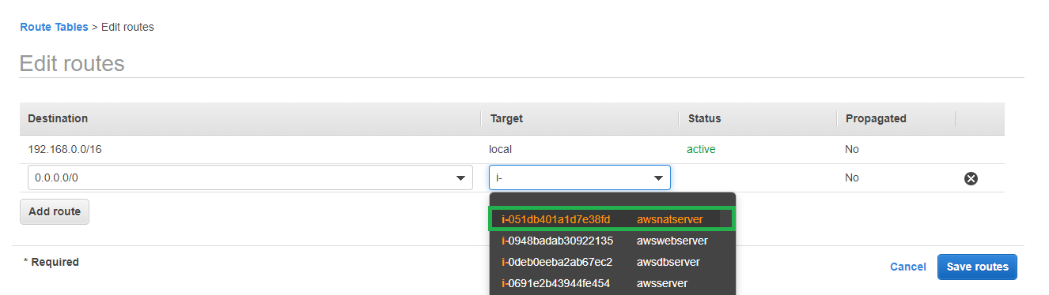

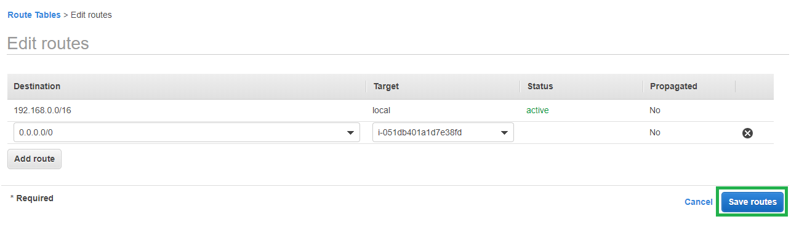

1. Connect to any of the private instance and check whether outbound internet access is working fine.

Before configuring NAT instance the private instance does not have outbound internet access.

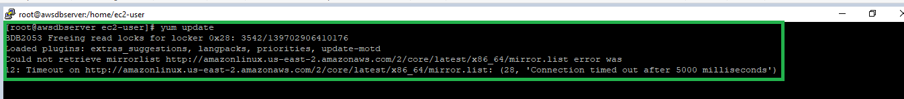

After configuring NAT instance the private instance able to connect to the internet and download software packages.

